Handson 07 -**Solution**

Create a MSK cluster and access it from EC2 instance.

1. Create one VPC and 3 subnets for the VPC. You can also use the default VPC and the associated subnets
2. Create one Internet gateway
3. Attach the internet gateway to your VPC

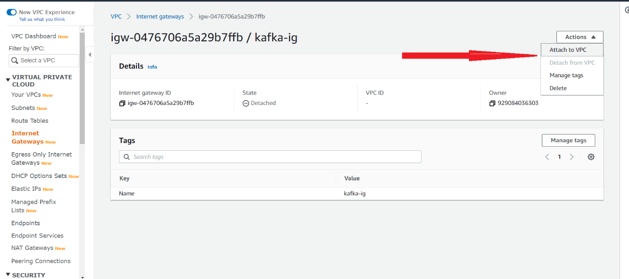

1. Click the “Route Tables” option on the left pane.

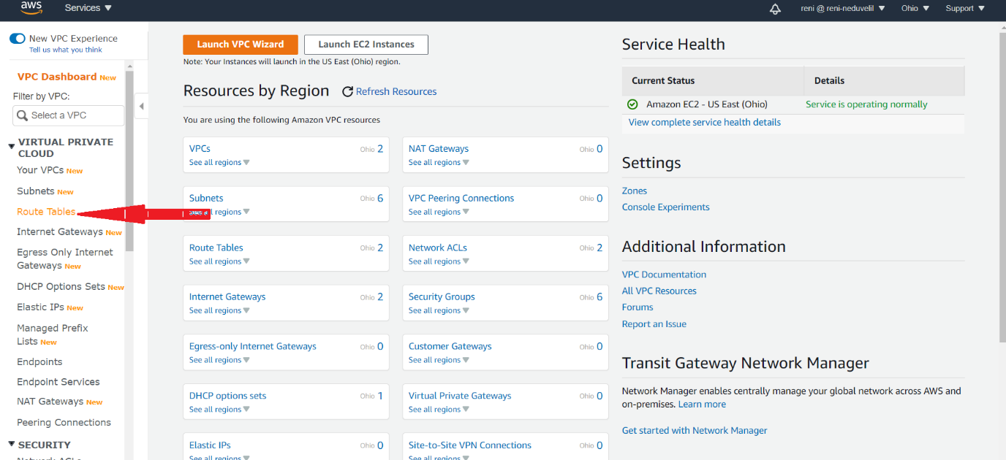

1. Select the route table of your VPC🡺Click on the Route tab🡺 Click Edit Routes
2. Add a new route where the target is your Internet gateway and click on the save button

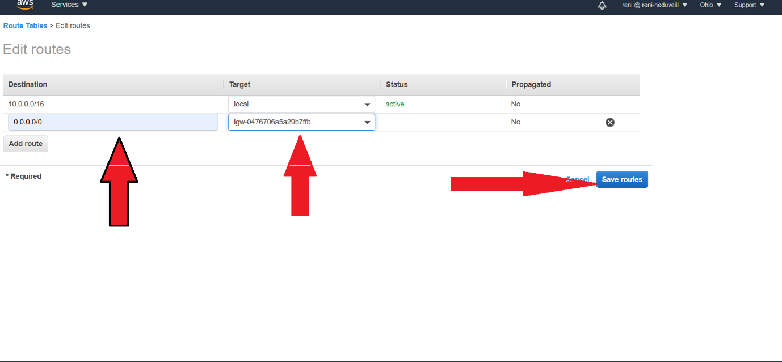

1. Now search for MSK in All Services Search Box.

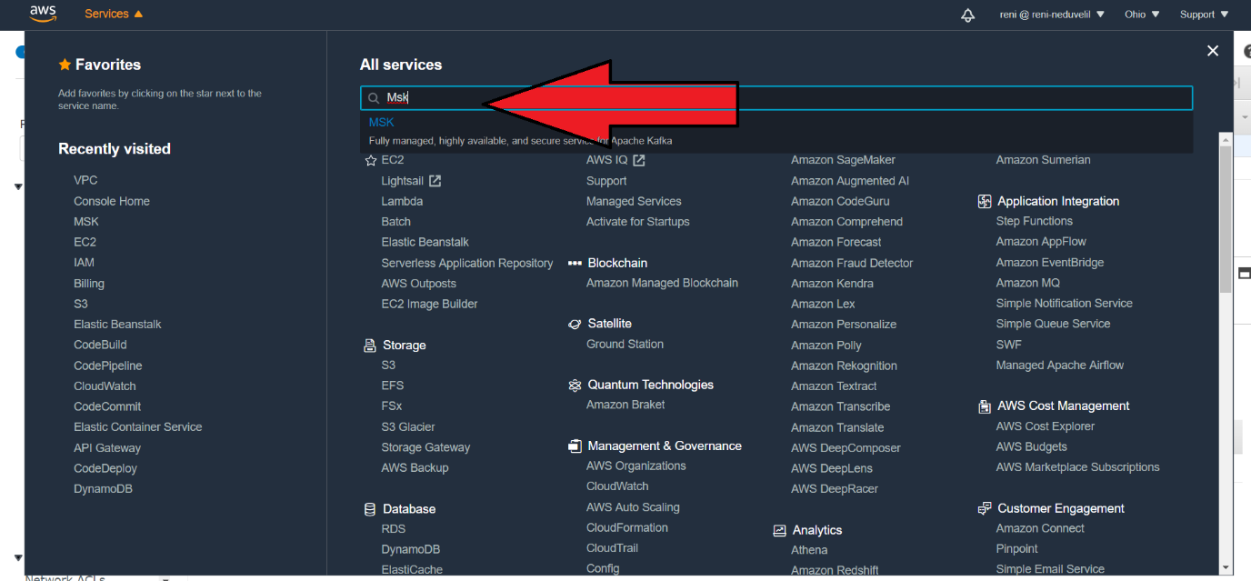

1. You will be taken to Amazon MSK screen as shown below

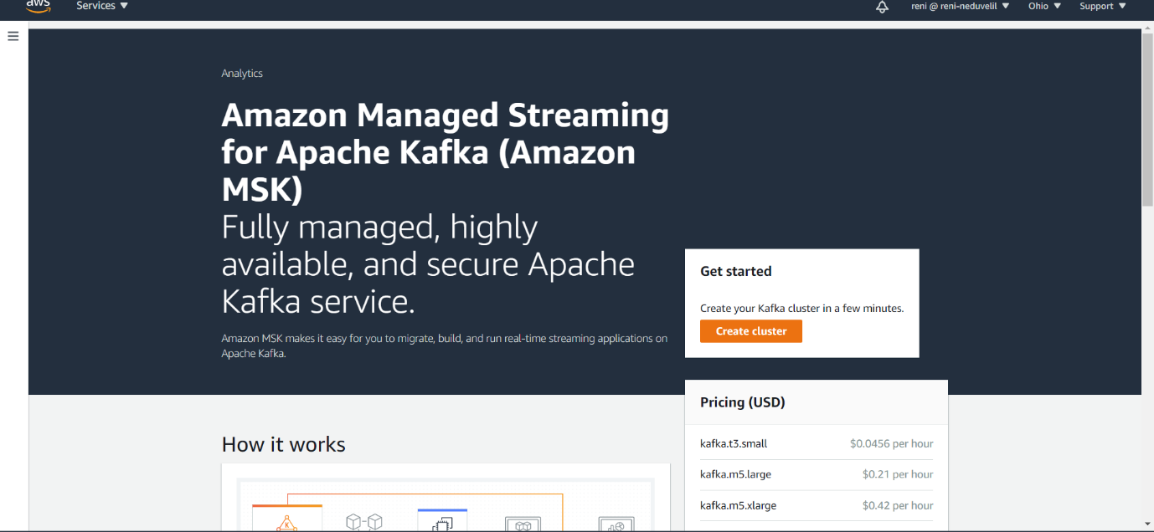

1. Click on “Create cluster” button. You will be taken to the screen shown below.
2. Select “Create cluster with custom settings”
3. Give a name for the cluster
4. Select the Kafka version

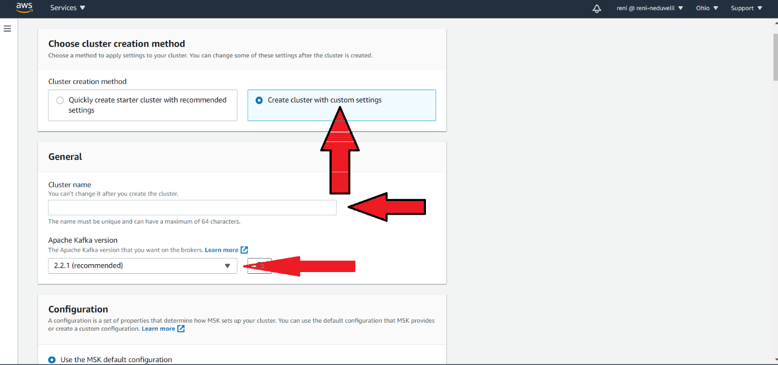

1. Select “Use the MSK default configuration”
2. Select your VPC.

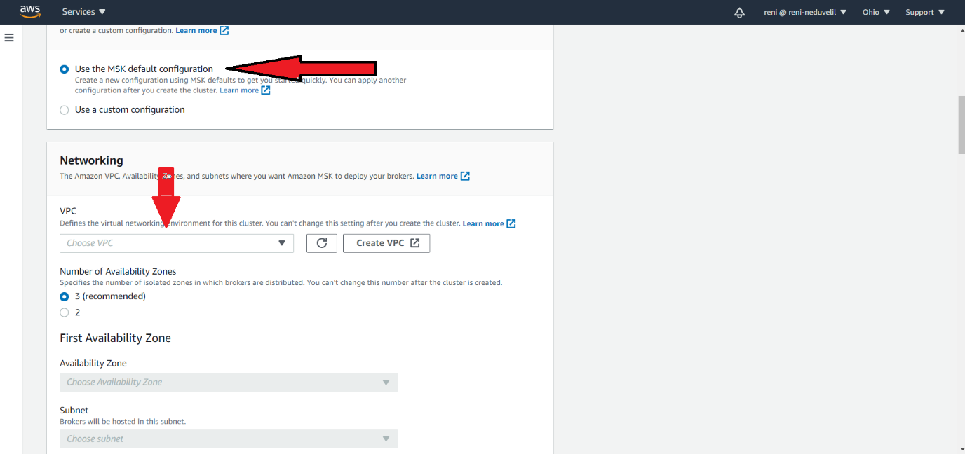

1. Select the “Number of availability zones” as per your requirement.
2. Select the Availability zones and the corresponding subnet.
3. update Number of brokers per availability zone to 1.

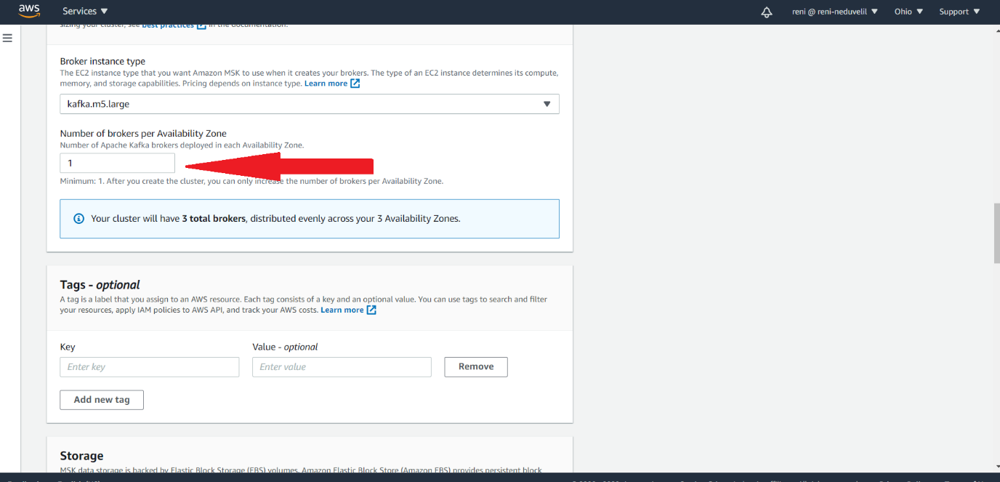

1. accept the default options for all other configurations and click on “Create cluster” button.
2. It will take 15 minutes for the cluster to be created.
3. Mean while go to the IAM service. Create a new Role

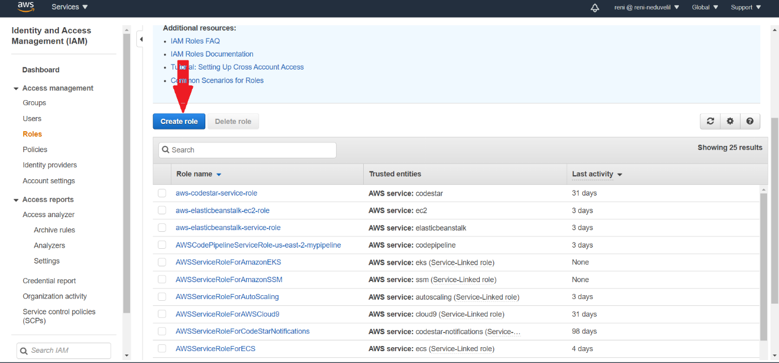

1. Select EC2 and click on Next button
2. Select the Policy “AmazonMSKFullAccess” and click “Next”

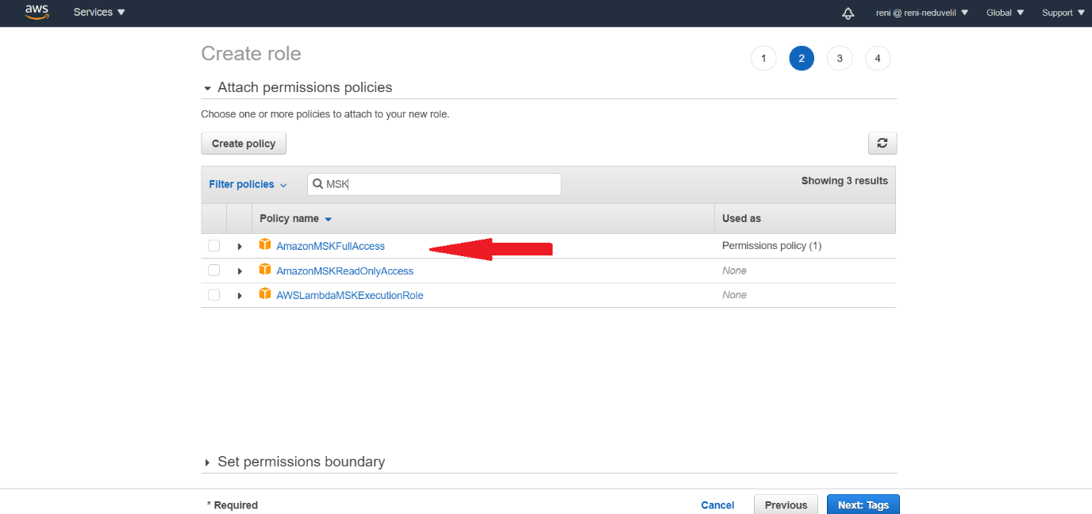

1. If you want a tag, provide a tag and click on “Next:Review”
2. Give a role Name and click on “Create role”

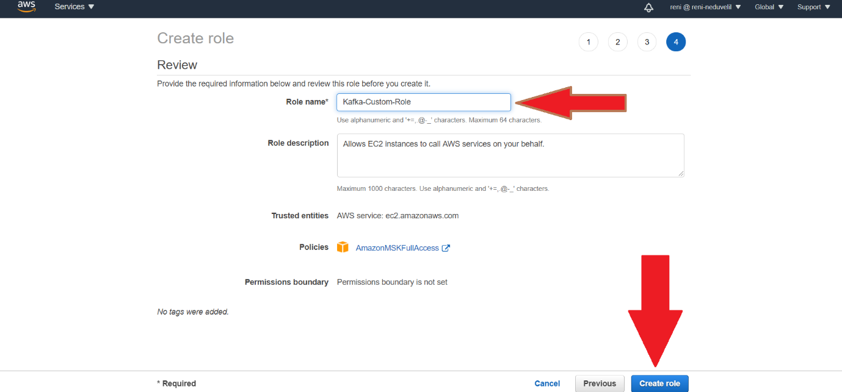

1. Create one EC2 instance.
2. Please make sure that in “Configure Instance Details” screen, IAM role which we have created in the previous step is selected.

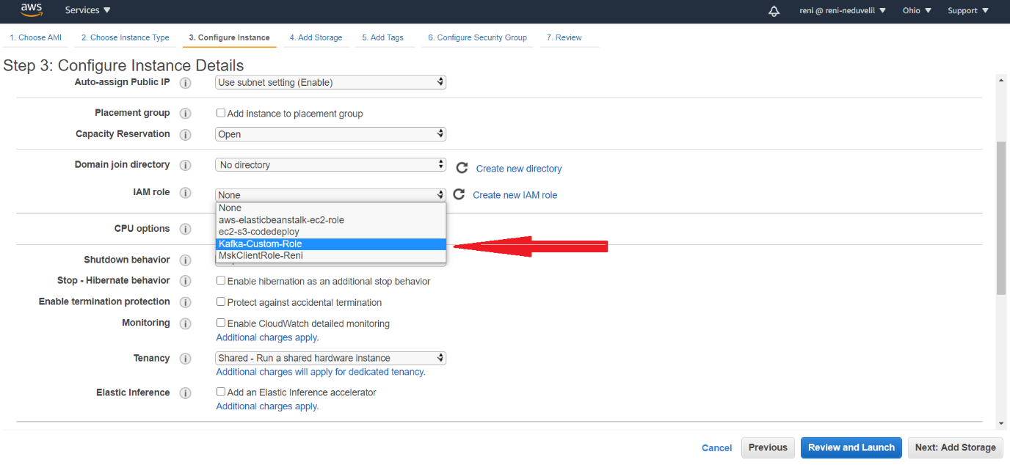

1. Connect to the EC2 instance we have created using SSH.
2. Issue the command “aws kafka list-clusters --region us-east-2”. Region should the region where you have created the MSK cluster.
3. You will get the details shown below. This command will give details of all the MSK clusters.

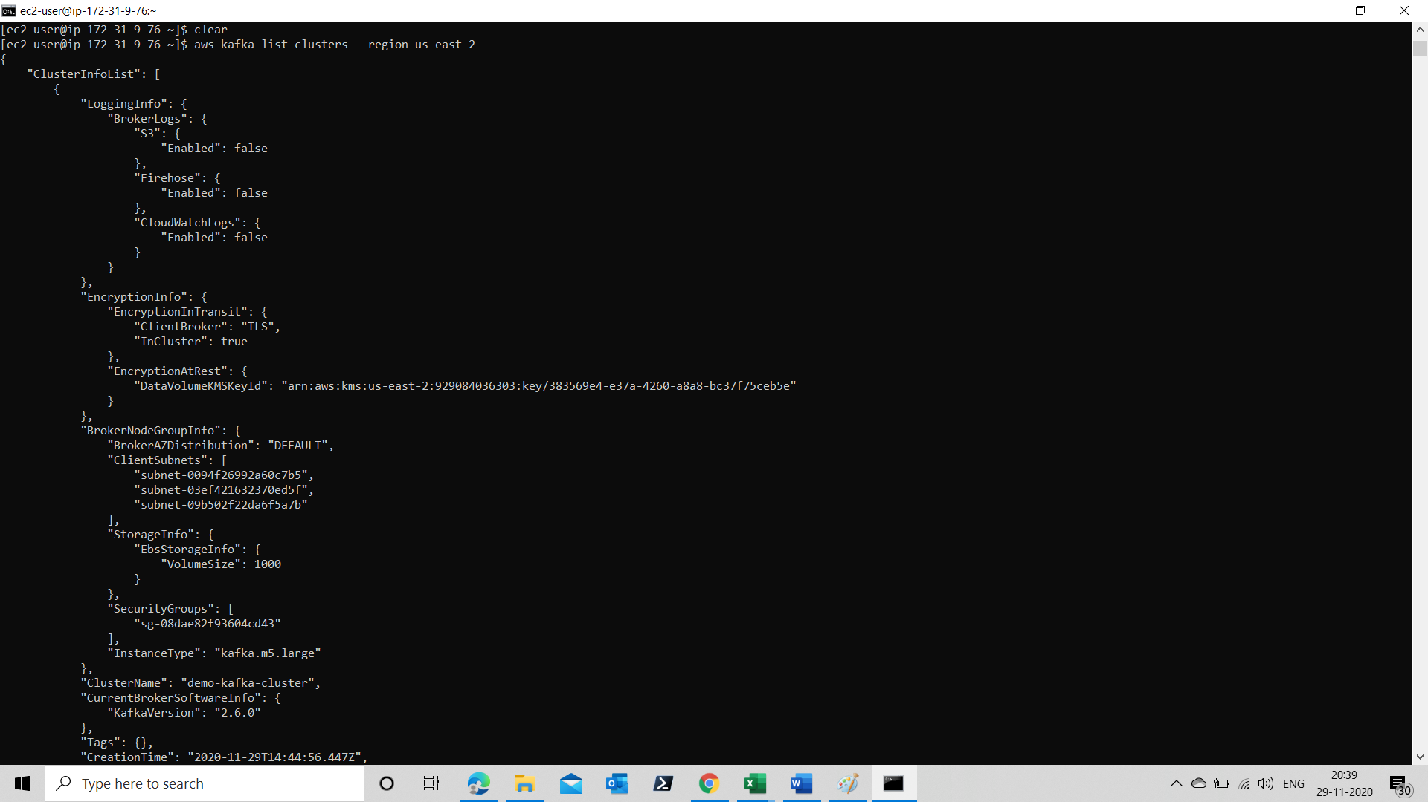

1. If you want the details of a specific cluster, you can issue the below mentioned command in the terminal.

aws kafka describe-cluster --cluster-arn arn:aws:kafka:us-east-2:929084036303:cluster/demo-kafka-cluster/5a194cfa-3942-481a-a0fd-ba8be9497c97-4 --region us-east-2

1. You will get the output as shown below.

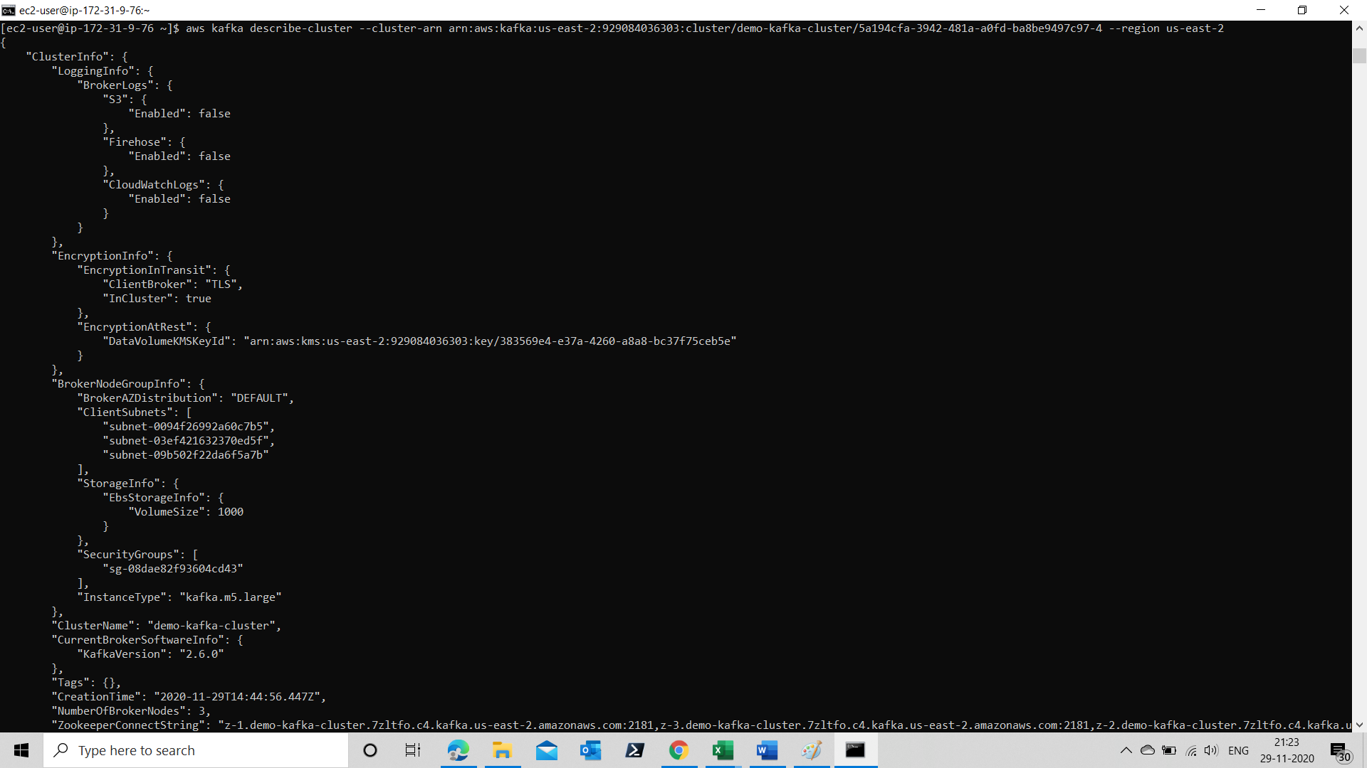

1. **Once you have done. Please make sure that all resources created by you should be deleted.**